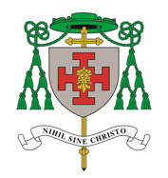
St. Gabriel’s
140 Lawton Road, Alsager
Stoke-on-Trent, ST7 2DE
Tel: 01270 877737
www.stgabrielsalsager.org.uk
St. Gabriel’s School & Playgroup, Tel: 875770 www.stgabriels.cheshire.sch.uk
St. Thomas More Catholic High School.
www.st thomasmore.cheshire.sch.uk

That
Parish Priest: Fr. Tony Grace
Permanent Deacon: Rev. Eddie Miller
Sunday 26th February 2017
Eighth Sunday In Ordinary Time

Parish Priest: Fr. Tony Grace
Permanent Deacon: Rev. Eddie Miller
Sunday 25th June 2017
12th Sunday of Ordinary Time


Parish Priest: Fr. Tony Grace
Permanent Deacon: Rev. Eddie Miller
22nd Sunday in Ordinary Time
31st August 2025
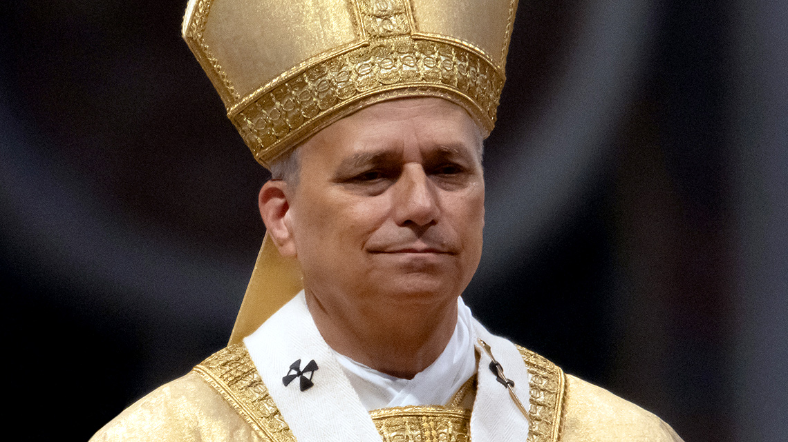

Michael Massey, President of the St Vincent de Paul Society at St Gabriel’s, will talk about the work of the SVP at the Masses on Friday 29th August 2025 through to Monday 1st September 2025. There will be a second Collection for the SVP at each Mass the following weekend.

The next Social Afternoon for senior citizens will be on Tuesday the 9th September from 2pm to 4pm in the Presbytery. There will be Bingo and the usual refreshments.
If you require a lift contact Michael Massey on 01270 872515 or 07510 223337.

There will be a FREE coach trip to Shrewsbury Cathedral on Saturday the 27th September 2025.
The coach will depart from St Gabriel’s Church at 9.15am and from St Anne’s at Nantwich at 9.45am. At 11.00am there will be a chance to see the Cathedral. Mass is at 12.15pm
From 1.00pm there will be free time in Shrewsbury. Depart Shrewsbury at 4pm.
If you would like to go, please enter your name and phone number on the list on the notice board. Any queries please contact Michael Massey on 01270 872515 or 07510 223337.
In the First Reading Sirach advises us to be thoughtful and attentive to others. We are to be modest, not seeking praise or approval for our action: everything good is a gift from God, and to be shared with others. The Psalm is a song of thanksgiving and hope, calling us to rejoice and trust in God’s care. Everyone is valuable in God’s eyes. This care for the suffering and oppressed points to Jesus, who came to serve the poor.
Jesus uses the setting of eating together at a feast to teach us the values of the Kingdom of God (Gospel). We are to put others before ourselves, showing kindness and compassion to everyone, especially those who cannot repay us. By following Jesus’s own values of selfless giving and humility, we radiate God’s love to others. We will be rewarded at the resurrection with our own place at the heavenly banquet.
The Second Reading presents Jesus as the mediator of the new covenant. Each of us can rejoice, celebrating our identity in God’s family, where everyone has the same rights as a firstborn child. As Pilgrims of Hope in this Jubilee year, we pray to be attentive and kind towards everyone we encounter this week. We think especially of those on the margins of society, and in areas of violence and war.

Crewe Pro-Life Group - March for LifeThe March for Life takes place this year in London on Saturday, 6th September 2025 Mary Jones, from the Warrington Shrine Church, is arranging a bus. The idea would probably be to have a stopping place at the Shell Garage on the Barthomley roundabout at Junction 16. Details can be worked out. If you are interested in going to the March, please contact Mary 07916578902 or Louise Kirk at lcskirk@gmail.com. The Crewe Pro Life group meet at 7:30 - 8:30 pm every first Wednesday of the month at St Marys Crewe. If you would like to join you would be very welcome.

Collection plate, contactless terminal in the church.
Please use your contactless debit/credit card or smart phone on our new DIGITAL / device to make a donation. Here is your webpage link to support the Mission of the Church in St Gabriel’s and through the Red Boxes and Missio, and the SVP to the poorest parts of the world or please scan QR code. Many thanks. https://donate.mydona.com/st-gabriel-alsager

Alsager Food Bank.
Thank you for your continued support for the important work of the Alsager food bank. Please keep your donations coming in. Donations of long-life items are always welcome, e.g. Tinned vegetables, fruit, meat, fish etc. Your continued generosity is much appreciated. Thank you.

PLEASE PRAY FOR THE ETERNAL REST OF THE RECENTLY DECEASED, Theresa Ann Flanagan, Stella Bailey, Yvonne Davies, Lucy Lynch, Sergio Colagcci, & those whose anniversaries occur around this time: Eric Cartlidge, Maureen Hudson, Benjamin Besa, Ethel Bagshaw, Catherine and Thomas Moakley, Connor Young, Joan Dwyer, Maureen Hudson.

PLEASE PRAY FOR THE SICK: Especially for Baby Dymond, Maureen Kesteven, Stuart Gresty, Valerie Condliffe, Agnes Mair, Lucía Capper, Kathleen Large, Sister Benedict, Michael Woolf, Barbara Fahy, George Lawton, Ben Thomas, Francis Dockery, Patricia & Willis Capp, Robin Wickham, Rita Jepson, Colin & Olga Lockhart, Pat Connors, Marie Bradley, Sheila Gilhooley, Brigid Smith, Maighread Tams, Brenda McDonagh, Margaret & Harold Barrow, Nicole Horsefield, Janet & Brian Woolf, Ann Cumberlidge, Miriam Howitt, Val Mason and all in our hospitals & nursing homes.

MASS TIMES WEEK COMMENCING 31st AUGUST 2025
Saturday 30th August  Ss Margaret Clitheroe, Margaret Ward & Anne Line  Sunday 31st August  22nd Sunday in Ordinary Time | 6.00 pm  Mass 6.30 pm  St. Gabriel’s Church  11.00 am  11.30 am. Mass.  St. Gabriel’s Church | Adoration & Confession  Maureen Hudson (Anniv), Theresa Ann Flanagan RIP, Eric Cartlidge RIP Dorothy Manson RIP, Catherine and Thomas Moakley (Anniv), Joan Dwyer (Anniv), and for Baby Dymond, Stuart Gresty (Sick),  Adoration & Confession  George Miller (Anniv), Ethel Bagshaw (Anniv), Barbara Hayes RIP, Benjamin Besa  (1st Anniversary), Eileen Grime (Anniv), and for all who are on our Parish Sick list
Monday 1st September  World Day of Special Prayer for the Care of Creation | 7.00 pm  7.30pm Mass  St. Gabriel’s Church | Adoration & Confession  Fr Robert Farrell RIP, Peter Prideaux-Brune RIP, May Shallow RIP, Fr.Greg Downing (Anniv), George Dorrian (Anniv), Cassie Shallow (sick), Kevin O’Neill (Sick), Robin Wickham (sick), Trevor Campbell, Bob Steele (sick), Colin & Olga Lockett (sick), Jo Shallow (sick), Sister Benedict.
Tuesday 2nd September | 10 am Mass  St Anne’s Nantwich | For the sick
Wednesday 3rdSeptember  St.Gregory the Great | No Service
Thursday 4th September  St. Cuthbert | 10 am Mass  St Anne’s Nantwich | Holy Souls
Friday 5th September | 9.30 am  10.00 a.m.  Mass St Gabriel’s | Holy Rosary, Adoration & Confession  Shrewsbury Secular Clergy,  Catherine & Thomas Moakley (Anniv), Hilary Leigh and Reg Leigh, (Anniversary), Frances Lovelady (Anniversary), and for Maureen Kesteven.
Saturday 6th September  The Blessed Virgin Mary  Sunday 7th September  23rd Sunday in Ordinary Time | 6.00 pm  Mass 6.30 pm  St. Gabriel’s Church  11.00 am  11.30 am. Mass.  St. Gabriel’s Church | Adoration & Confession  Eric Cartlidge (5th Anniv)  and for all who are on our Parish sick list.  Adoration & Confession  Benjamin Besa (1st Anniversary)  And for all who are on our Parish Sick list
Please contact Fr Tony a.grace3007@btinternet.com for newsletter items
Collection last weekend came to £466.26p. Many thanks for your Offerings.
Diocese of Shrewsbury, Registered Charity Number 234025
Parish Safeguarding Officer, Paul Hassell 07795200353

Collection plate, contactless terminal in the church.
Please use your contactless debit/credit card or smart phone on our new DIGITAL / device to make a donation. Here is your webpage link to support the Mission of the Church in St Gabriel’s and through the Red Boxes and Missio, to the poorest parts of the world or please scan QR code. Many thanks. https://donate.mydona.com/st-gabriel-alsager

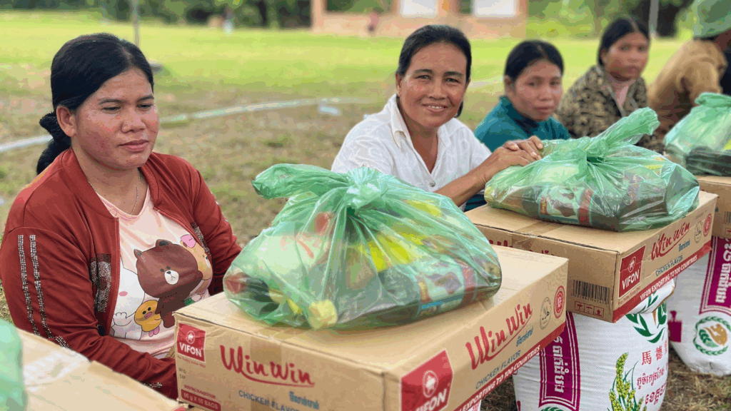
In July 2025 a five-day conflict along the Cambodia-Thailand border broke out. Despite a swiftly negotiated ceasefire, dozens of people were killed and more than 260,000 others were forced to flee their homes.

https://missio.org.uk/cambodia-fr-glenn-mhm-asks-for-prayers/

Each month the Pope asks us to pray for a particular intention. All of the Holy Father’s intentions are provided for you in our Mission Today magazine and online below.
Download the latest version of Mission Today.

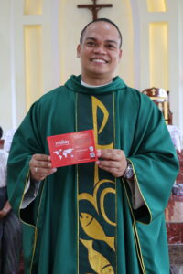

Fr Glenn, Mill Hill Missionary, with the Red Box. Fr Glenn, a Mill Hill Missionary who is not far from the Cambodian-Thai border, recently got in touch to update us on the situation.
Fr Glenn is the Parish Priest of St Mary Mother of God in Toumpong, a rural community in Cambodia which is close to the Thai border. He shares that, although the ceasefire which was brokered between the neighbouring nations is holding so far, the ground is far from firm beneath them, and many of the displaced families are now seeking refuge around Toumpong.
Fr Glenn’s mission, which is supported by Missio, has always had a large pastoral element. In Cambodia, most priests have more than one church to look after and must travel for miles through the countryside to reach them.
Responding to the immediate need
Fr Glenn is no stranger to helping families who are struggling for food and other basic needs. So it’s unsurprising that the church is already on hand to help new families in search of help and safety. He shares:
‘So many things are happening now. We are occupied helping displaced families affected by the conflicts in the border. We are helping them with food packs are these are most needed now. Our friends in Cambodia are generously supporting with packs of food supplies.’
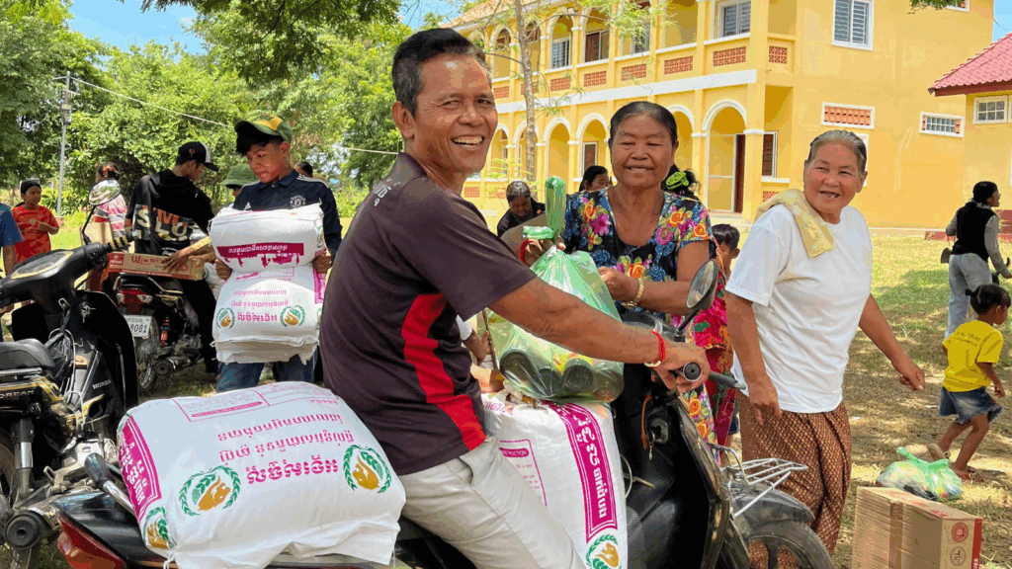
Please pray for Cambodia
Meanwhile, Fr Glenn asks that we keep his community and the whole of Cambodia and Thailand in our prayers. His request is simple:
‘We really need prayers for peace.’
Please join us to hold our sisters and brothers in need in prayer at this tense time.

The Jubilee Prayer
By praying the official Prayer, we join with our global family, to use the same words to express gratitude to God for the Jubilee experience and request the grace of forgiveness.
Father in heaven,
may the faith you have given us
in your son, Jesus Christ, our brother, and the flame of charity enkindled in our hearts by the Holy Spirit, reawaken in us the blessed hope for the coming of your Kingdom.
May your grace transform us
into tireless cultivators of the seeds of the Gospel.
May those seeds transform from within both humanity and the whole cosmos in the sure expectation
of a new heaven and a new earth,
when, with the powers of Evil vanquished,
your glory will shine eternally.
May the grace of the Jubilee reawaken in us, Pilgrims of Hope,
a yearning for the treasures of heaven. May that same grace spread
the joy and peace of our Redeemer throughout the earth.
To you our God, eternally blessed, be glory and praise for ever.
Amen

- 
- About

- News
- Our Work
  - 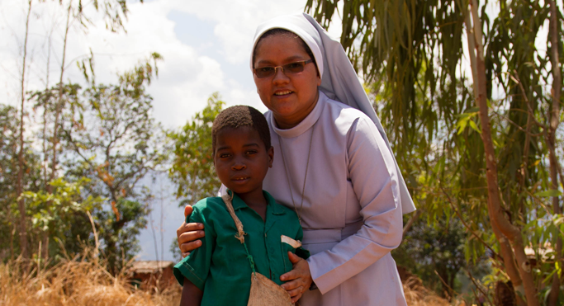

  - 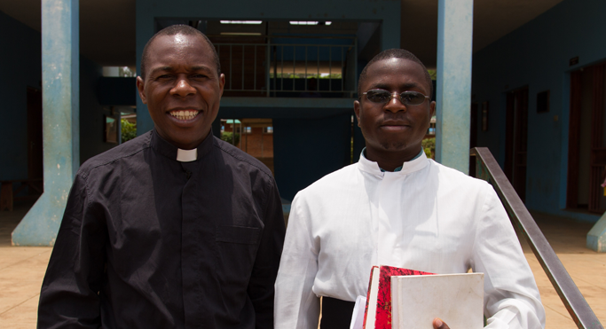

  - 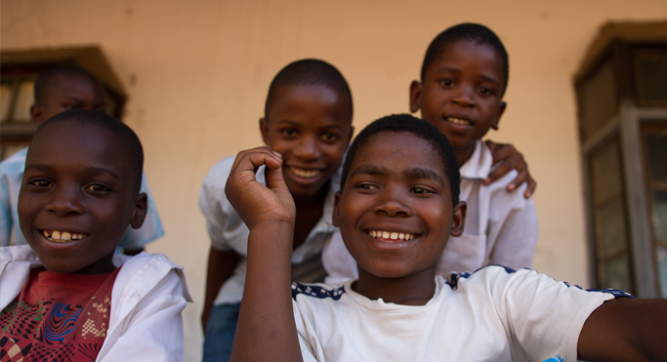

  - 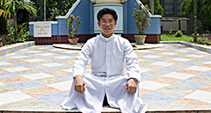

- Get Involved

- Appeals

- Schools

- Contact

- Donate nowPope’s Prayer Intention – August 2025
- >
- News>
- Pope’s Prayer Intention – August 2025

In August, let us pray with Pope Leo XIV that those societies where coexistence seems more difficult do not succumb to the temptation of confrontation for ethnic, political, religious, or ideological reasons.
‘May the witness of believers be for our world a leaven of authentic hope, a harbinger of new heavens and a new earth (cf. 2 Peter 3:13), where men and women will dwell in justice and harmony, in joyful expectation of the fulfilment of the Lord’s promises.’
Pope Francis, Jubilee 2025 letter, 25

Our Focus for August
- Please join us to pray for peace around the world this August: for the many countries currently in a state of war or conflict and for the many millions of innocent people caught in the crossfire. You can join our weekly Mission Rosary to pray each week for the needs of every continent.
- Together we are supporting missionaries around the world in igniting God’s hope and love wherever they are needed the most.

