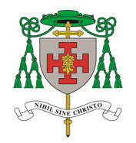
St. Gabriel’s
140 Lawton Road, Alsager
Stoke-on-Trent, ST7 2DE
Tel: 01270 877737
www.stgabrielsalsager.org.uk
St. Gabriel’s School & Playgroup, Tel: 875770 www.stgabriels.cheshire.sch.uk
St. Thomas More Catholic High School.
www.st thomasmore.cheshire.sch.uk

That
Parish Priest: Fr. Tony Grace
Permanent Deacon: Rev. Eddie Miller
Sunday 26th February 2017
Eighth Sunday In Ordinary Time

Parish Priest: Fr. Tony Grace
Permanent Deacon: Rev. Eddie Miller
Sunday 25th June 2017
12th Sunday of Ordinary Time


Parish Priest: Fr. Tony Grace
Permanent Deacon: Rev. Eddie Miller
21st Sunday in Ordinary Time
24th August 2025
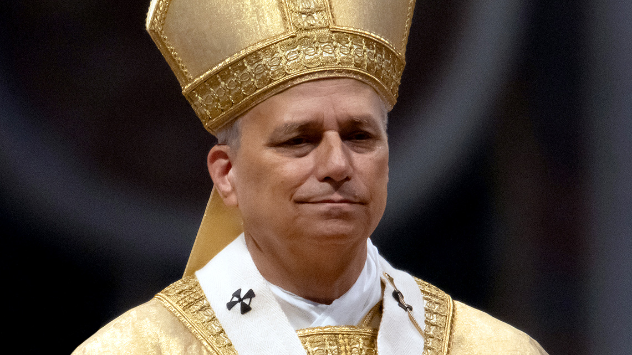

There will be a FREE coach trip to Shrewsbury Cathedral on Saturday the 27th September 2025.
The coach will depart from St Gabriel’s Church at 9.15am and from St Anne’s at Nantwich at 9.45am. At 11.00am there will be a chance to see the Cathedral. Mass is at 12.15pm
From 1.00pm there will be free time in Shrewsbury. Depart Shrewsbury at 4pm.
If you would like to go, please enter your name and phone number on the list on the notice board. Any queries please contact Michael Massey on 01270 872515 or 07510 223337.

Pope Leo’s message for the World Day of Prayer for the Care of Creation 2025 August 2025. In his message for the Tenth World Day of Prayer for the Care of Creation, Pope Leo stresses that environmental justice – implicitly proclaimed by the prophets – can no longer be regarded as an abstract concept or a distant goal. It is an urgent need that involves much more than simply protecting the environment. For it is a matter of justice – social, economic and human. For believers it is also a duty born of faith, since the universe reflects the face of Jesus Christ, in whom all things were created and redeemed. In a world where the most vulnerable of our brothers and sisters are the first to suffer the devastating effects of climate change, deforestation and pollution, care for creation becomes an expression of our faith and humanity. Now is the time to follow words with deeds. “Living our vocation to be protectors of God’s handiwork is essential to a life of virtue; it is not an optional or a secondary aspect of our Christian experience” (Laudato Si’, 217). By working with love and perseverance, we can sow many seeds of justice and thus contribute to the growth of peace and the renewal of hope. It may well take years for this plant to bear its first fruits, years that, for their part, involve an entire ecosystem made up of continuity, fidelity, cooperation and love, especially if that love mirrors the Lord’s own self-sacrificing Love.

Crewe Pro-Life Group - March for Life
The March for Life takes place this year in London on Saturday, 6th September 2025
Mary Jones, from the Warrington Shrine Church, is arranging a bus. The idea would probably be to have a stopping place at the Shell Garage on the Barthomley roundabout at Junction 16. Details can be worked out. If you are interested in going to the March, please contact Mary 07916578902 or Louise Kirk at lcskirk@gmail.com. The Crewe Pro Life group meet at 7:30 - 8:30 pm every first Wednesday of the month at St Marys Crewe. If you would like to join you would be very welcome.

Collection plate, contactless terminal in the church.
Please use your contactless debit/credit card or smart phone on our new DIGITAL / device to make a donation. Here is your webpage link to support the Mission of the Church in St Gabriel’s and through the Red Boxes and Missio, to the poorest parts of the world or please scan QR code. Many thanks. https://donate.mydona.com/st-gabriel-alsager

St.Augustine was baptized by Ambrose in April of 387, became a priest in 391 and Bishop of Hippo in 395. There is so much more to this great saint’s life. He wrote many great works and was a Doctor of the Church. But it is his conversion that has given millions of Christians since then, the hope that anyone can be brought back home to the Church, to God.
If you feel torn between the allure of the world and the promises of salvation, you are not alone. We all feel that. But the Lord is always seeking you. He is always planting seeds and putting people in our lives who can bring us back to Him.
We must reach out to God. We must put aside our pride and our love of our own sin. We have to choose the good and choose the Lord. If Augustine can do it, we can too. As he is known for saying, “Our hearts are restless until they rest in you.”
St. Augustine of Hippo died August 28, 430. He was canonized by popular acclaim and made a Doctor of the Church by Pope Boniface VIII in 1298. He is the patron saint of brewers, printers and theologians.

Alsager Food Bank.
Now the school holidays are underway there is more need than ever to support the important work of the food bank. Please keep your donations coming in. Your continued generosity is much appreciated.

PLEASE PRAY FOR THE ETERNAL REST OF THE RECENTLY DECEASED, Peter Hunt, Laurence Kelly, Stella Bailey, Yvonne Davies, Lucy Lynch, Kevin Dean, Sergio Colacgci, & those whose anniversaries occur around this time: Eric Cartlidge, Ken Strong, Margaret Hewetson, Mark Costigan, Hilary Leigh, Reg Leigh, Frances Lovelady, Frances and Tom Byatt, Benjamin Besa, Michael Parden, Joan Parden, David Parden, Catherine and Thomas Moakley, Connor Young, Joan Dwyer.
PLEASE PRAY FOR THE SICK: Especially for Baby Dymond, Maureen Kesteven, Valerie Condliffe, Agnes Mair, Lucía Capper, Kathleen Large, Sister Benedict, Michael Woolf, Barbara Fahy, George Lawton, Ben Thomas, Francis Dockery, Patricia & Willis Capp, Robin Wickham, Rita Jepson, Colin & Olga Lockhart, Pat Connors, Marie Bradley, Sheila Gilhooley, Brigid Smith, Maighread Tams, Brenda McDonagh, Margaret & Harold Barrow, Nicole Horsefield, Janet & Brian Woolf, Ann Cumberlidge, Miriam Howitt, Maureen Whittiker and all in our hospitals & nursing homes.
MASS TIMES WEEK COMMENCING 24th AUGUST 2025
Saturday 23rd August  St Rose of Lima  Sunday 24th August  21st Sunday in Ordinary Time | 6.00 pm  Mass 6.30 pm  St. Gabriel’s Church  11.00 am  11.30 am. Mass.  St. Gabriel’s Church | Adoration & Confession  Ken Strong (Anniversary), Frances & Tom Byatt (Anniv), Dorothy Manson RIP, Catherine and Thomas Moakley (Anniv), Joan Dwyer (Anniv), and for Baby Dymond.  Adoration & Confession  25th Wedding Anniversary of Mark and Nicola Rayner, 40th Wedding Anniversary of Joanne & Andrew Brookes, Barbara Hayes RIP, Margaret Hewetson (6th Anniversary), Benjamin Besa (1st Anniversary), And for all who are on our Parish Sick list
Monday 25th August  St. Thomas of Hereford | 7.00 pm  7.30pm Mass  St. Gabriel’s Church | Adoration & Confession  Fr Robert Farrell RIP, Peter Prideaux-Brune RIP, May Shallow RIP, Fr.Greg Downing (Anniv), Robin Wickham (sick), Trevor Campbell, Bob Steele (sick), Colin & Olga Lockett (sick),
Tuesday 26th August  Blessed Dominic of the Mother of God Barberi | 10 am Mass  St Anne’s Nantwich | For the sick
Wednesday 27thAugust  St Monica | No Service
Thursday 28th August  St Augustine of Hippo | 10 am Mass  St Anne’s Nantwich | Holy Souls
Friday 29th August  The Passion of John the Baptist | 9.30 am  10.00 a.m.  Mass St Gabriel’s | Adoration & Confession  Catherine & Thomas Moakley (Anniv), Hilary Leigh and Reg Leigh, (Anniversary), Frances Lovelady (Anniversary), and for Maureen Kesteven.
Saturday 30th August  Ss Margaret Clitheroe, Margaret Ward & Anne Line  Sunday 31st August  22nd Sunday in Ordinary Time | 6.00 pm  Mass 6.30 pm  St. Gabriel’s Church  11.00 am  11.30 am. Mass.  St. Gabriel’s Church | Adoration & Confession  Ken Strong (Anniversary)  Eric Cartlidge (5th Anniv)  and for all who are on our Parish sick list.  Adoration & Confession  Benjamin Besa (1st Anniversary)  And for all who are on our Parish Sick list
Please contact Fr Tony a.grace3007@btinternet.com for newsletter items
Collection last weekend came to £466.36p. Many thanks for your Offerings.
Diocese of Shrewsbury, Registered Charity Number 234025
Parish Safeguarding Officer, Paul Hassell 07795200353

Collection plate, contactless terminal in the church.
Please use your contactless debit/credit card or smart phone on our new DIGITAL / device to make a donation. Here is your webpage link to support the Mission of the Church in St Gabriel’s and through the Red Boxes and Missio, to the poorest parts of the world or please scan QR code. Many thanks. https://donate.mydona.com/st-gabriel-alsager

Pope’s Prayer Intention – August 2025

In August, let us pray with Pope Leo XIV that those societies where coexistence seems more difficult do not succumb to the temptation of confrontation for ethnic, political, religious, or ideological reasons.
‘May the witness of believers be for our world a leaven of authentic hope, a harbinger of new heavens and a new earth (cf. 2 Peter 3:13), where men and women will dwell in justice and harmony, in joyful expectation of the fulfilment of the Lord’s promises.’
Pope Francis, Jubilee 2025 letter, 25

Our Focus for August at missio.org.uk
- Please join us to pray for peace around the world this August: for the many countries currently in a state of war or conflict and for the many millions of innocent people caught in the crossfire. You can join our weekly Mission Rosary to pray each week for the needs of every continent.
- Together we are supporting missionaries around the world in igniting God’s hope and love wherever they are needed the most.

- 
- About

- News
- Our Work
  - 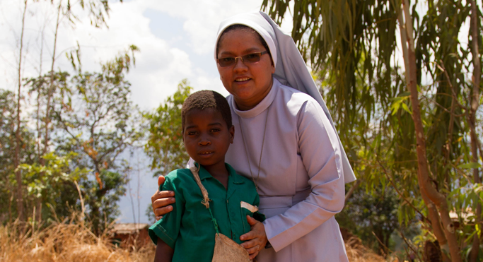

  - 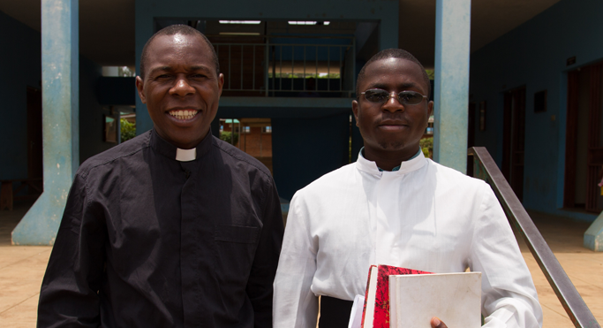

  - 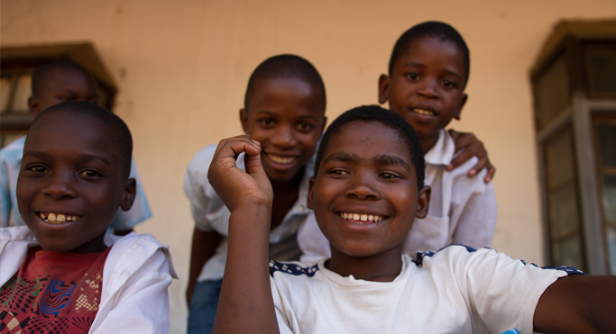

  - 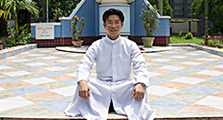

- Get Involved

- Appeals

- Schools

- Contact

- Donate nowPope’s Prayer Intention – August 2025
- >
- News>
- Pope’s Prayer Intention – August 2025
In August, let us pray with Pope Leo XIV that those societies where coexistence seems more difficult do not succumb to the temptation of confrontation for ethnic, political, religious, or ideological reasons.
‘May the witness of believers be for our world a leaven of authentic hope, a harbinger of new heavens and a new earth (cf. 2 Peter 3:13), where men and women will dwell in justice and harmony, in joyful expectation of the fulfilment of the Lord’s promises.’
Pope Francis, Jubilee 2025 letter, 25

Our Focus for August
- Please join us to pray for peace around the world this August: for the many countries currently in a state of war or conflict and for the many millions of innocent people caught in the crossfire. You can join our weekly Mission Rosary to pray each week for the needs of every continent.
- Together we are supporting missionaries around the world in igniting God’s hope and love wherever they are needed the most.

